Nama : Sulis Tiyah

No BP : 2001081002

**Tahapan membuat RESTful API**

Businnes Flow ==> UI/UX Screen ==> API Documentation ==> Develop RESTful API

* Businnes Flow

|  |  |  |
| --- | --- | --- |
| **Daftar** | **Login** | **Form Mahasiswa** |
| Nama | Username | No BP |
| Email | Password | Nama Lengkap |
| Username |  | Jurusan |
| Password |  | Prodi |
| RePassword |  | Tempat Tanggal Lahir |
|  |  | Jenis Kelamin |
|  |  | Agama |
|  |  | No Telp |
|  |  | Alamat |

* UI/EX Screen

1. Halaman Daftar

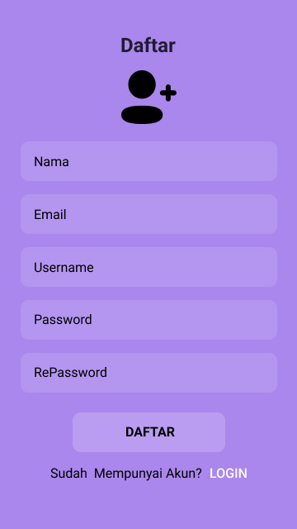

1. Halaman Login

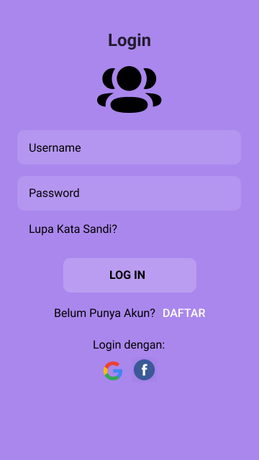

1. Halaman Data Mahasiswa

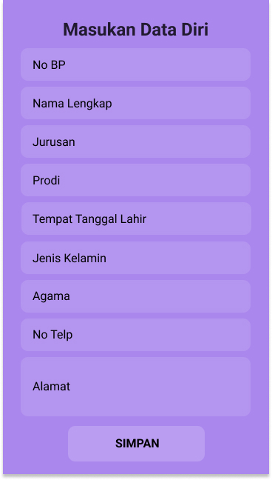

* API Documentation

|  |  |  |
| --- | --- | --- |
| **Daftar** | **Login** | **Form Mahasiswa** |
| POST/daftar | POST/login | POST/form_mahasiswa |
|  |  | GET/form_mahasiswa |
|  |  | GET/form_mahasiswa/:no_bp |
|  |  | PUT/form_mahasiswa/:no_bp |
|  |  | DELETE/form_mahasiswa/:no_bp |

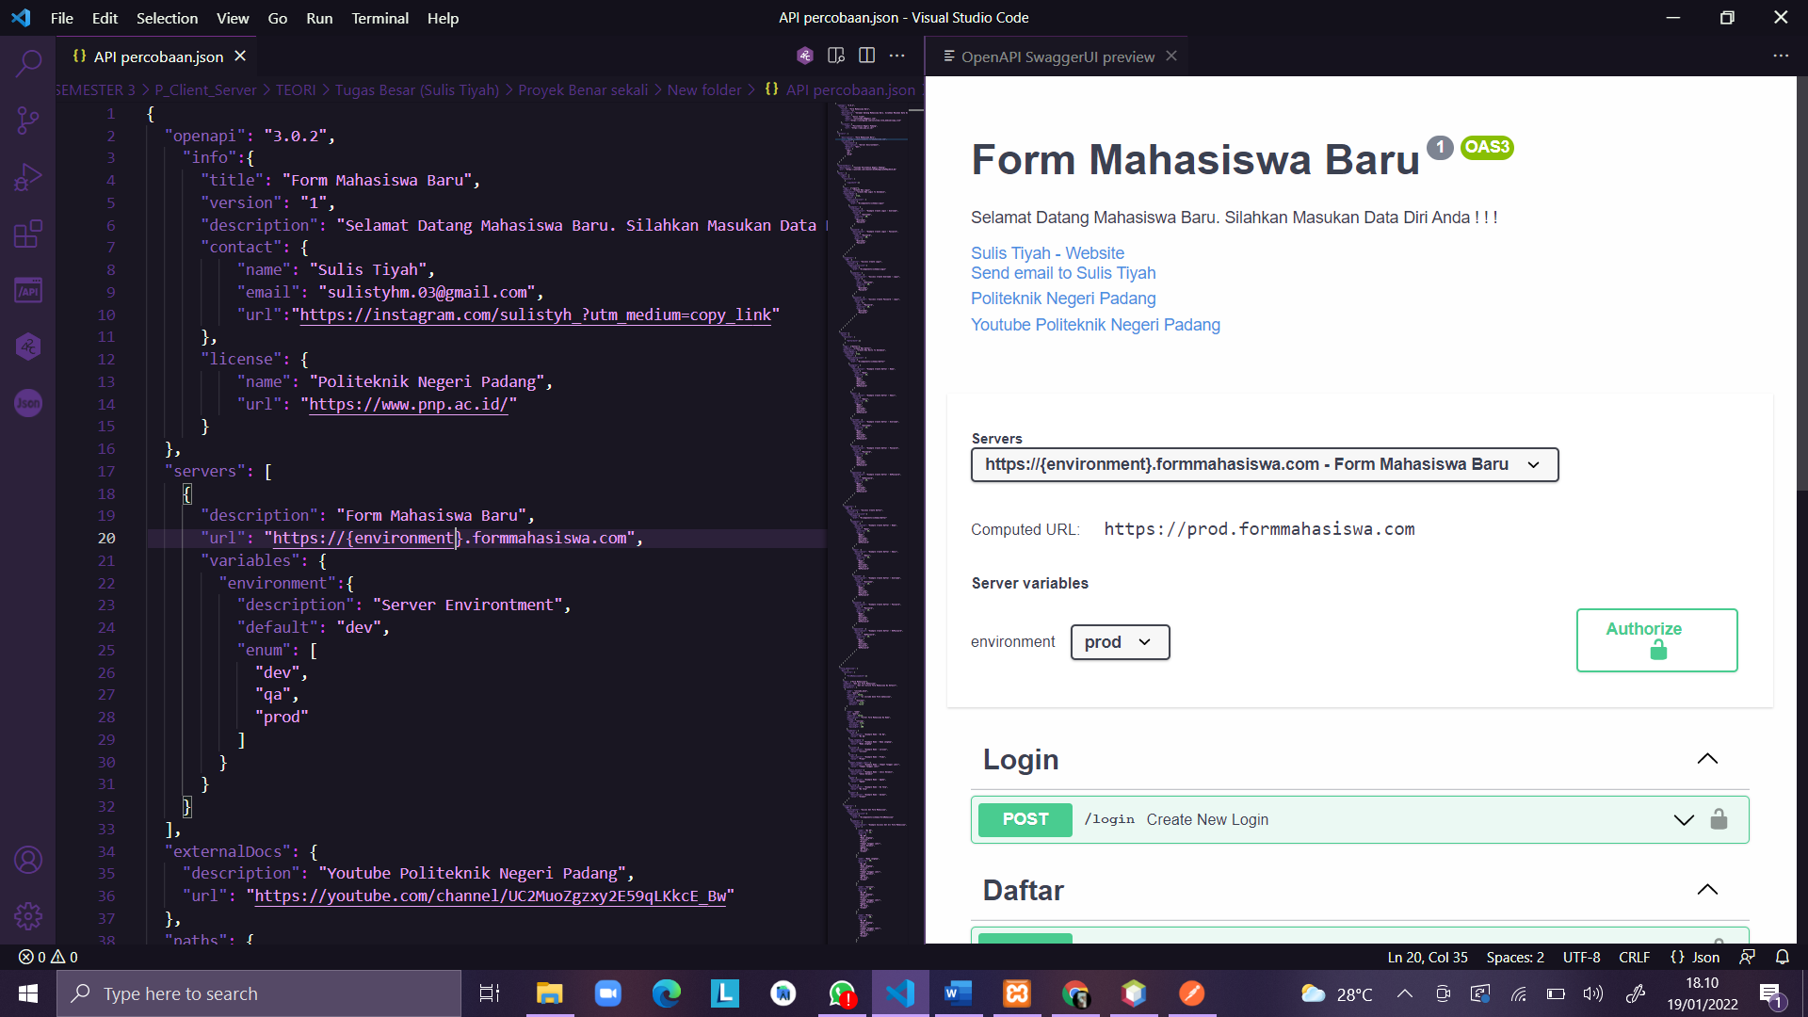

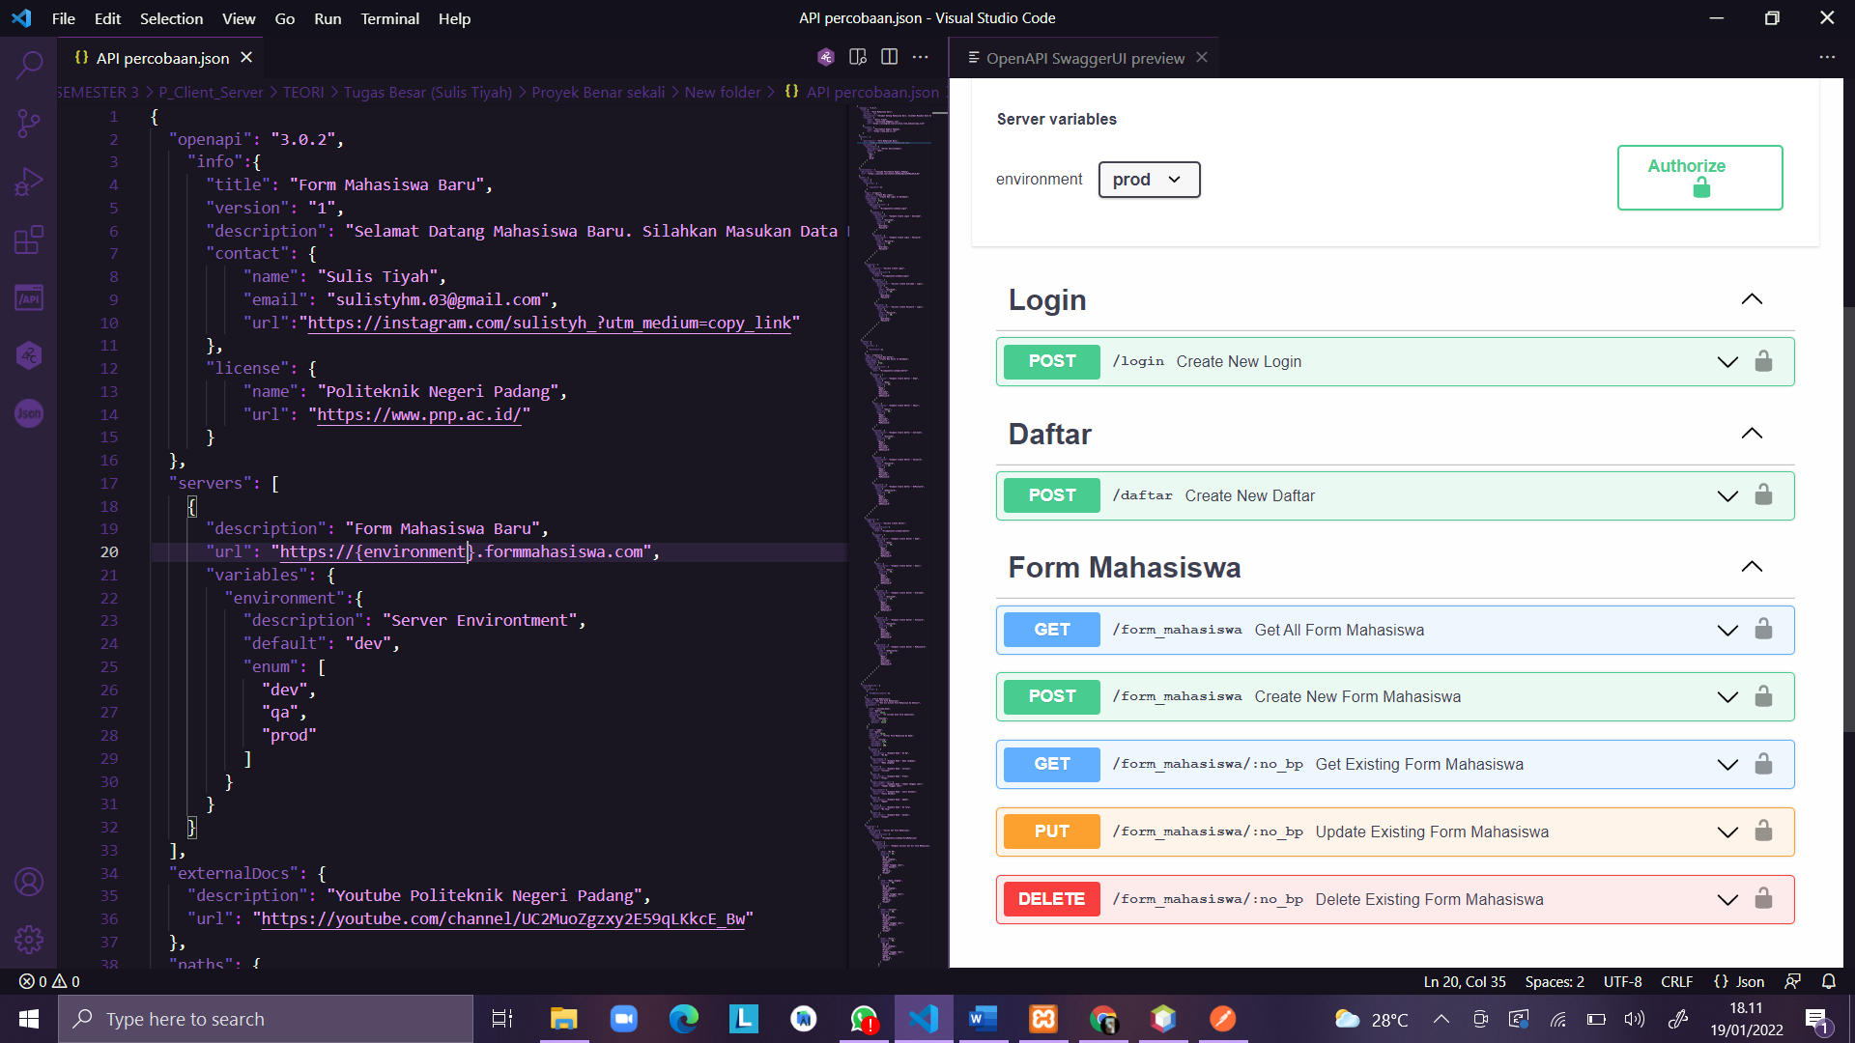

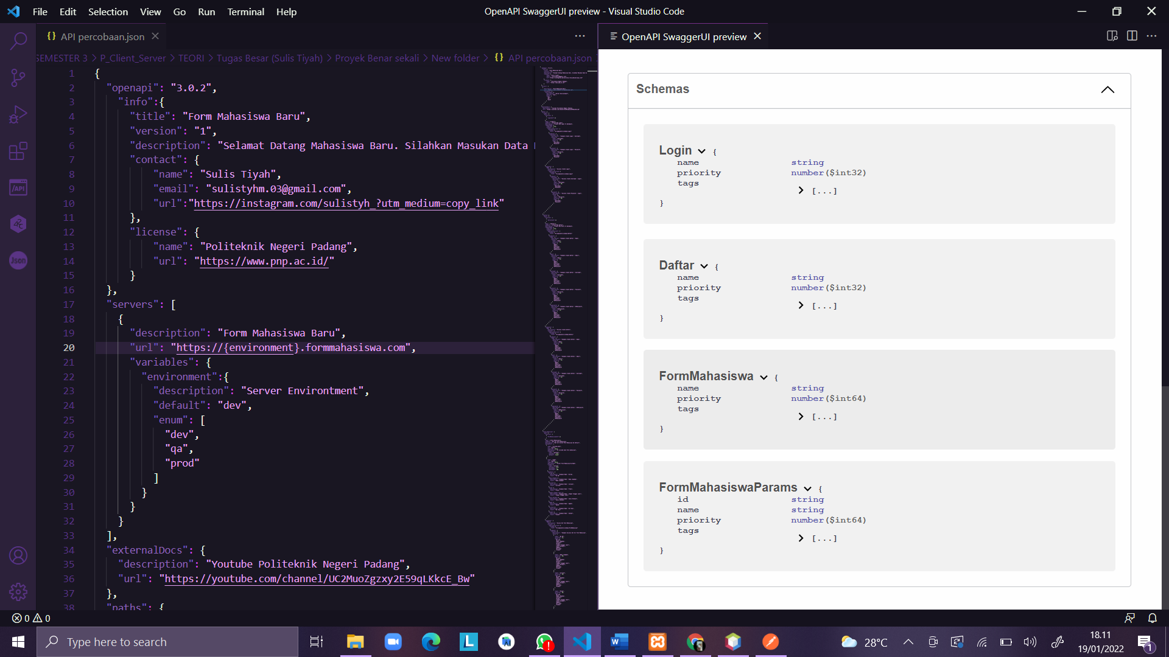

* Develop RestFul API

